Palak Paneer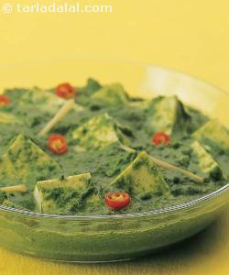

Many of the greatest loved vegetarian Punjabi cusions are the ones where paneer is joined with a vegetable. This mixture of spinach and paneer is not only extremely healthy, but is a superb combination of taste, quality and flavour. The paneer in this technique has been fried to add some advance flavour.

Blanch the spinach in a vesselful of boilingwater for 2 to 3 minutes. Drain, refresh with cold water and keep aside to cool for sometime. Blend in a mixer to a smooth purée and keep aside. Heat the oil in a kadhai , add the onions and sauté on a medium flame till they turn translucent. Add the garlic, ginger, green chillies and turmeric powder and sauté on a medium flame for 1 to 2 minutes. Add the tomato pulp and sauté till themixture leaves oil, while stirring continuously. Add the spinach purée and 2 tbsp of water, mix well and cook on a medium flame for 2 minutes. Add the salt, garam masala and fresh cream and mix well. Add the paneer, mix gently and cook on a medium flame for another 1 to 2 minutes.